**Mr. Computer website**

Ahmad Alghamdi | 2036980

**Problem statement:**

Mr. computer is a website shop for building and upgrading your dream gaming PC, We are passionate gamers ourselves, and we understand the importance of having the right hardware to level up your experience, so we created this store to make it easy for you to decide and buy the right hardware at special prices.

**Website format:**

The website has 5 pages:

1 – Main page:

This page (named index.html in file) is the main landing page that contains the company’s logo and showcase of the products of the shop.

Screenshots:

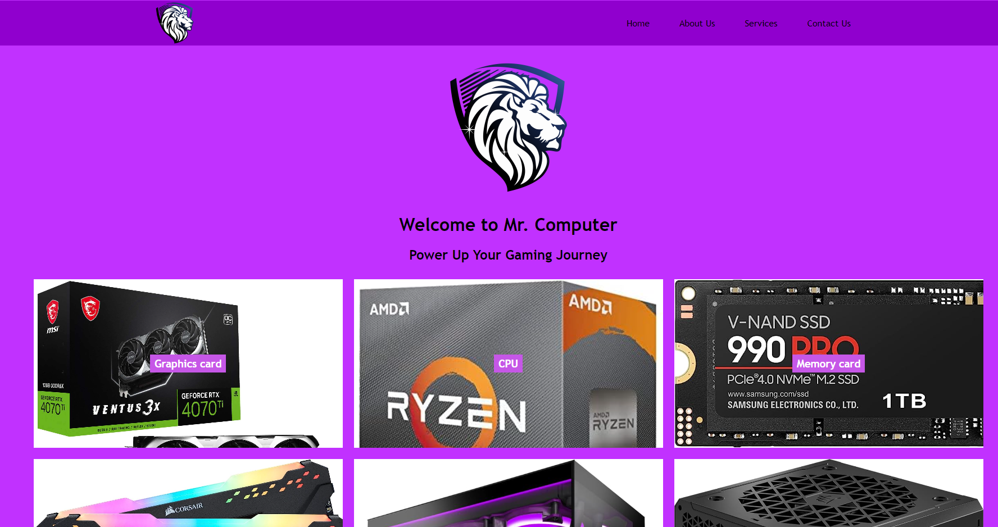

2 – about us:

This page contains a brief description Mr. computer and what type of offers do have, also contains the brands that has sponsored this store.

Screenshots:

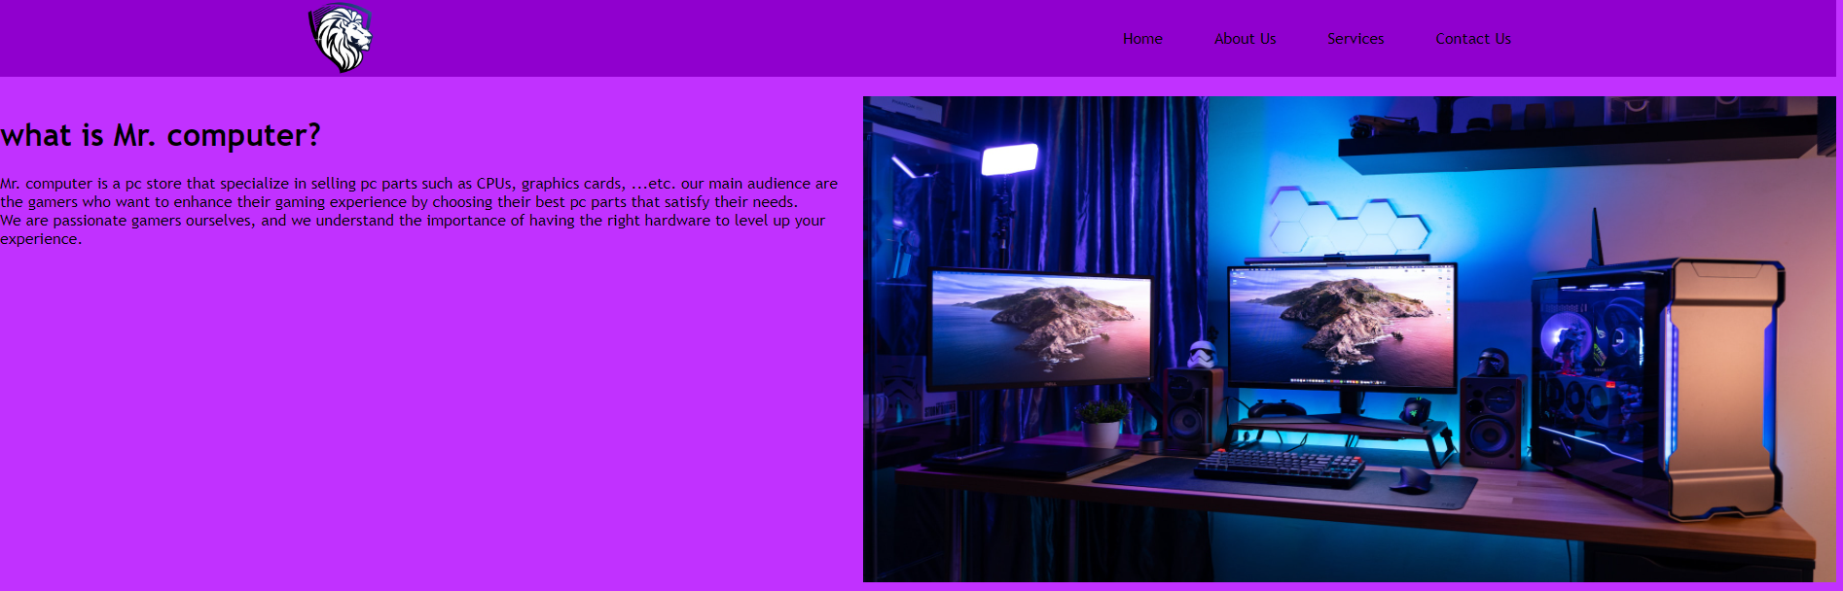

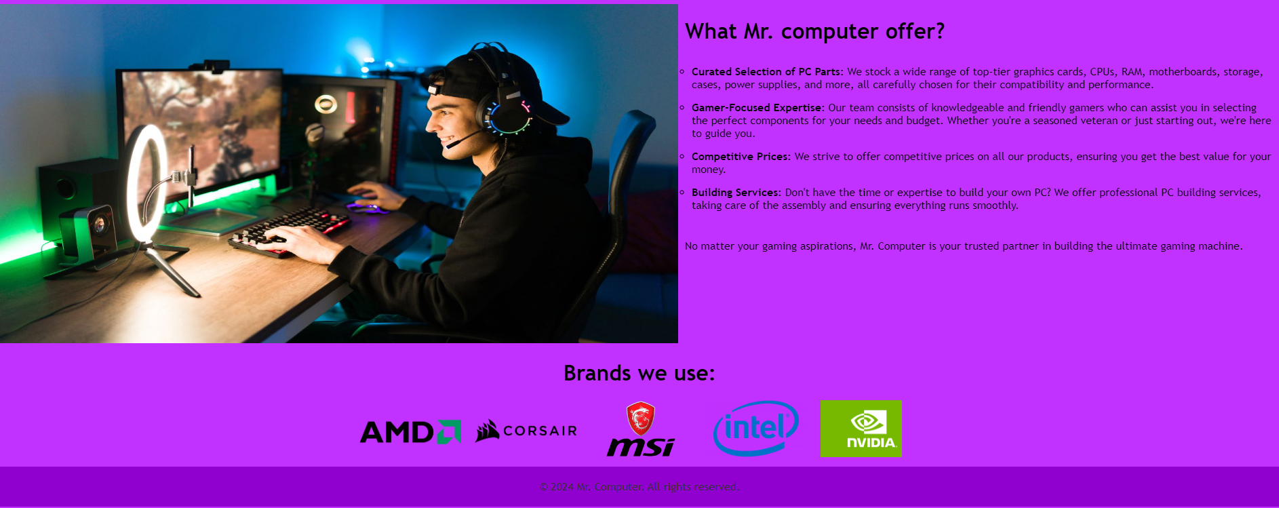

3 – services:

This page contains all the products that the store sells and some other services such as building a pc

Screenshots:

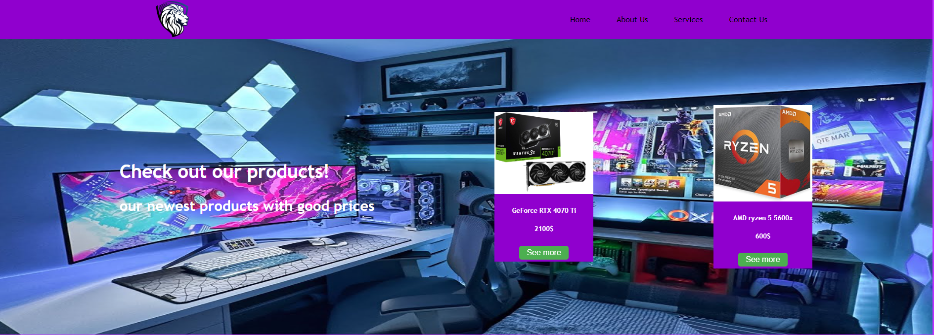



4 – product page (RTX 4070 TI):

From services page you can click on ‘see more’ in a product and it will show you the everything about the product including it’s description, key features, and a picture of it. If the user liked it, he can click on ‘add to cart’ so it can be added to his shopping cart (the shop cart is not created yet). I used one of our product as an example, GeForce RTX 4070 TI from Nvidia

Screenshots:

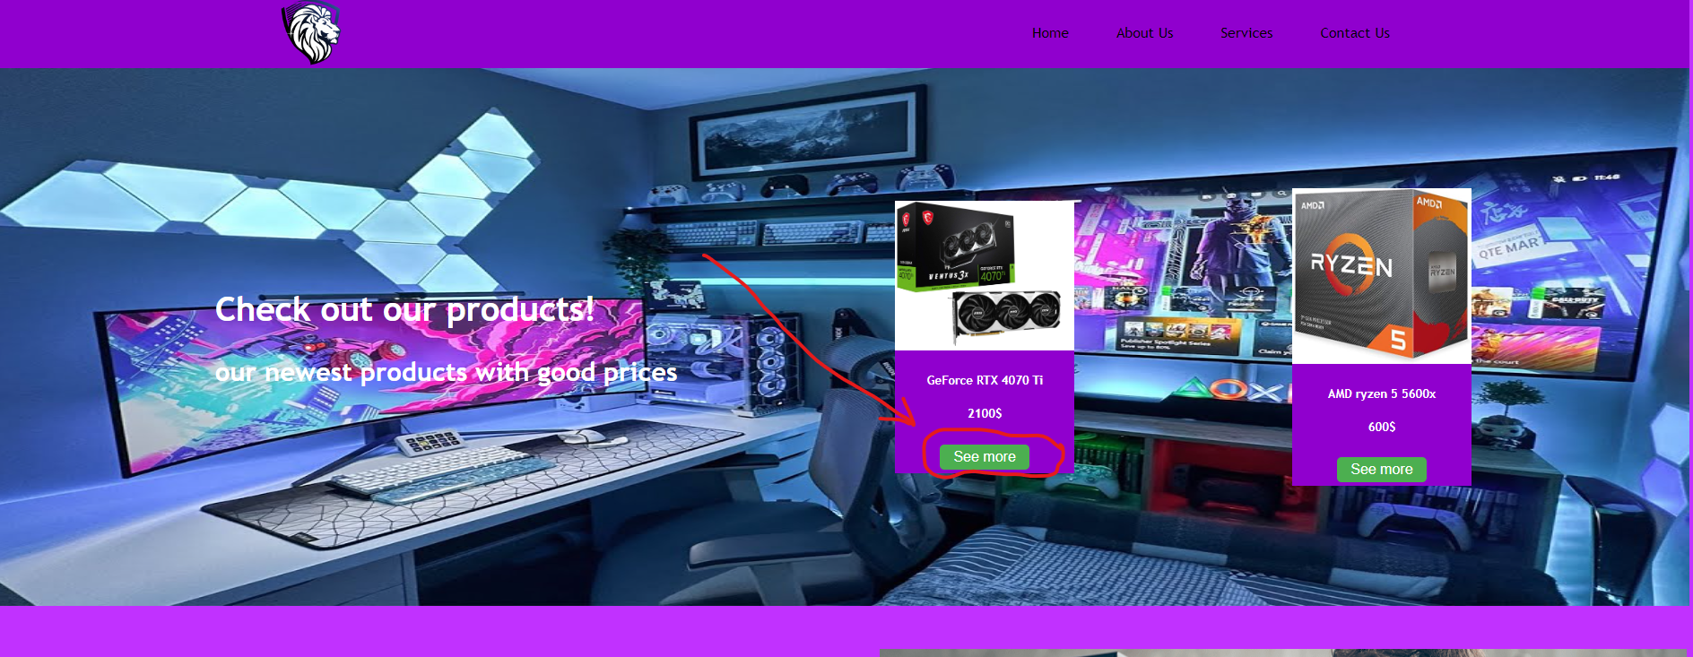

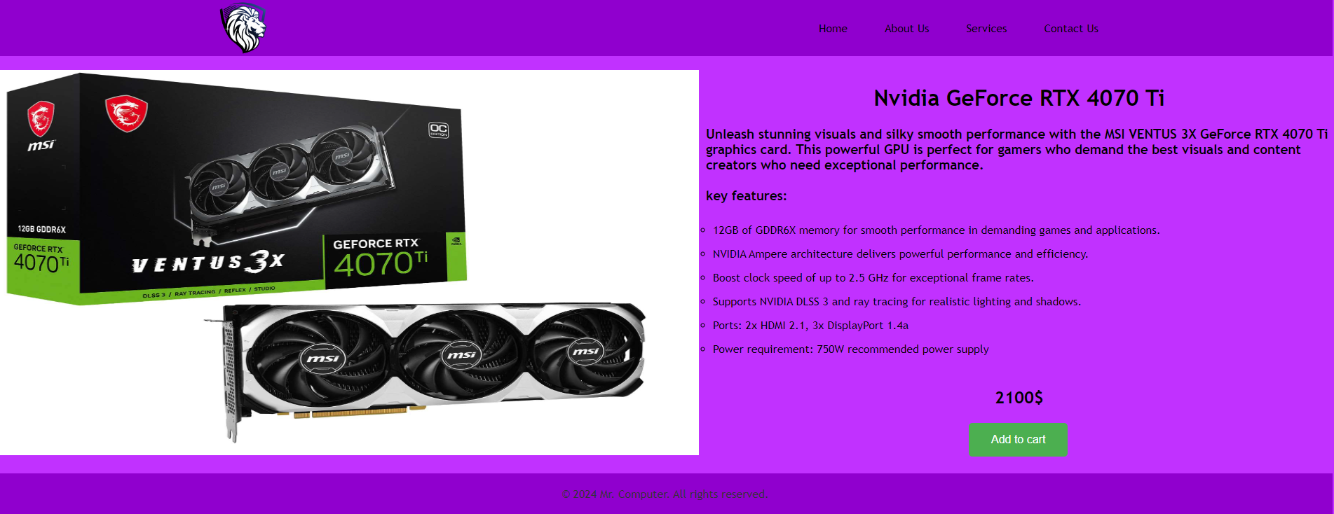

5 – Contact us:

This page contains all our contact information:

* Main office address
* Phone number
* Fax
* Email

Also, the user can email us directly from this page.

Screenshots:

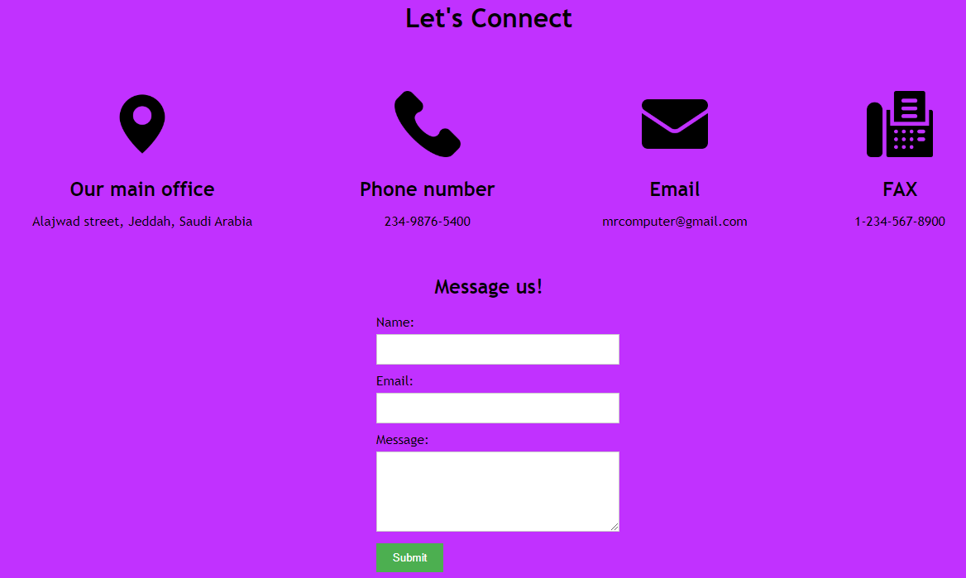

**Website link:**